**Iterative Software Development Life Cycle:**

Two different way of looking at the iterative design process.

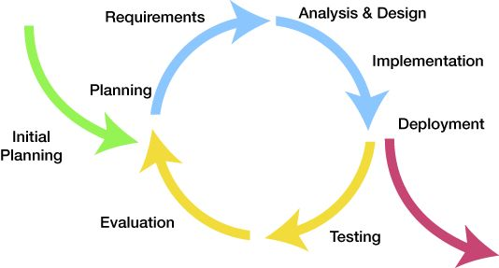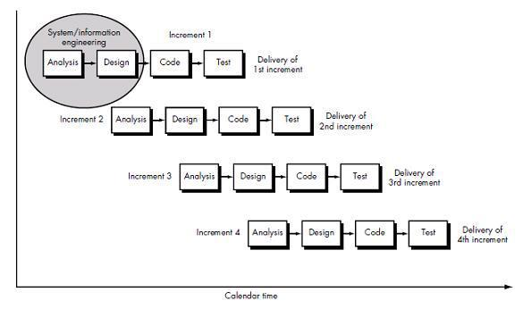

Iterative development was created as a response to problems found in the waterfall model. The general idea is to develop the software in iterations, small portions at a time.

Many developers use an iterative approach. Select a requirement, analyse / design / implement / test / & repeat. This has the advantage of getting a basic version working early and then develop it step-by step, from one working version to the next. After the initial gathering and discovery of requirements and initial planning, the iterative approach lends itself well to breaking the design into modules and therefore object-oriented design and programming.

Each iteration focuses on one or more parts or modules of the project. When it is developed that iteration is implemented, deployed and tested. This quickly gives the client a version to look at and give feedback about. Any needed changes can be incorporated into the next or later iteration. During testing and evaluation of an iteration the next iteration can already be adding additional requirements and working on analysis and design. This process repeats until all requirements are met.

There are several advantages to this type of process. Quickly getting a version to the client helps to keep the client happy and seeing that process is being made. This also helps to identify any issues or changes that the client wants early in the process. It also has the advantage that different stages can be happening at the same time. While Iteration (n) is being tested and evaluated, iteration (n+1) can also be in analysis and design, with different people working on the different stages at the same time. This process is also flexible, being much easier to make changes part way thru than say the waterfall method. Testing is focused on one part that allows for faster detection of problems and greater reliability. Another advantage is that this method, with its early releases and greater flexibility, often leads to a cost and time savings. The iterative process can be used in both small and large projects.

The modularity, flexibility, efficiency, and quick deliverables of the iterative process are the reasons we choose to use this software development cycle.

Sources:

Software Development Models: Iterative and Incremental Development (January 21st,2014) Retrieved from <https://technologyconversations.com/2014/01/21/software-development-models-iterative-and-incremental-development/>

Iterative and incremental development – Wikipedia (January 18th, 2018) Retrieved from <https://en.wikipedia.org/wiki/Iterative_and_incremental_development>